Chapter 1, Problem 35.

The graph in Fig. 1.33 represents the power drawn by an industrial plant between 8:00 and 8:30 A.M. Calculate the total energy in MWh consumed by the plant.

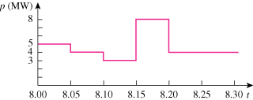

Figure 1.33
For Prob. 1.35.

